**Collaboration provides homeless Pods in Milford Haven**

**What is homelessness?**

The biggest misconception when considering someone as homeless is that this only applies when you are living on the streets, this is just one form. The message I would like to convey is that you do not have to be sleeping on the streets to be homeless!

Even if you have a roof over your head you can still be homeless. Perhaps you are sofa surfing at a friends’ place, or staying somewhere temporarily like a hostel, night shelter or bed & breakfast. It might be that you are living in very poor conditions or somewhere that is not suitable for you or your family.

If you do not have a place to call home, it is likely that you are experiencing ‘hidden homelessness’.

People can become homeless for all kinds of reasons, these may include - being evicted by your landlord, losing your job, health problems, relationship breakdown, a disaster such as fire or flooding.

Armed with this information, on the 14th of January I decided I would embark on an adventure and trial one of the homeless pods that have been created in partnership with Pembrokeshire County Council and Naomi and Steve Joseph of the Church in Nantucket. The Pods are not seen as a long-term option - hence the 7-day short stay period, but they do give shelter, warmth, and a bit of stability, which is something our clients are crying out for while they seek the help, they need to address their situation.

I arrived at my digs for the night around 4pm, with in all honesty a little apprehension of what I was letting myself into. I was met by Naomi the brain behind this fantastic operation.

**Ed & Dan**

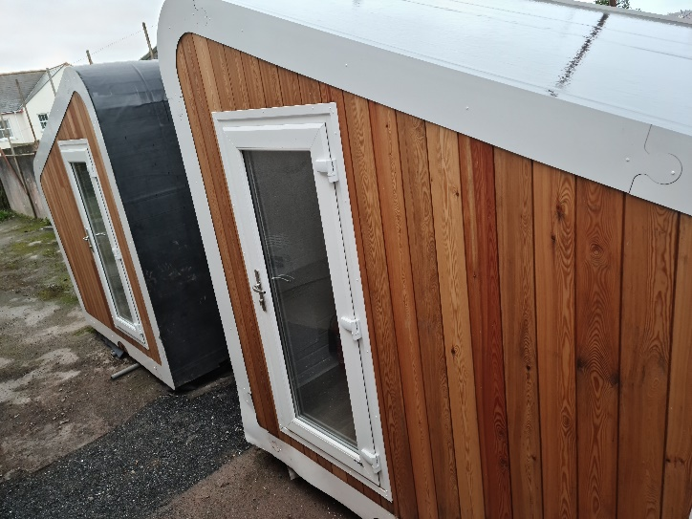After swapping pleasantries Naomi asked what I wanted to do first and I couldn’t wait to see where I’d get my head down for the evening, Naomi took me to the sleeping Pods and I have to say my first thought was wow, I needn’t have worried, my next thought was “have I stumbled across a Nordic Sauna” ... The pods are not only functional but look great and not what you would consider homeless temporary accommodation to look like!

They are not massive, but they do not need to be, its all about the functionality and what they can bring to those who will be using them. A roof, warmth, and security.

As there are 2 Pods, our very own Cathy Lawrence contacted Naomi to ask how we would differentiate between them ‘call them Pod 1 and 2?’ Naomi decided Ed and Dan…. What’s the reason behind this I hear you ask? After Ed Sheeran and Daniel Craig two fairly well-known people in the celebrity world.

Did you know that before making it they also slept rough? Me neither! The important message with the naming of these pods…. ‘**Your current situation doesn’t have to define you!’** I think using those names and the message behind will help to inspire and shows despite how low and how bad things can seem, things can change.

**The Third Place**

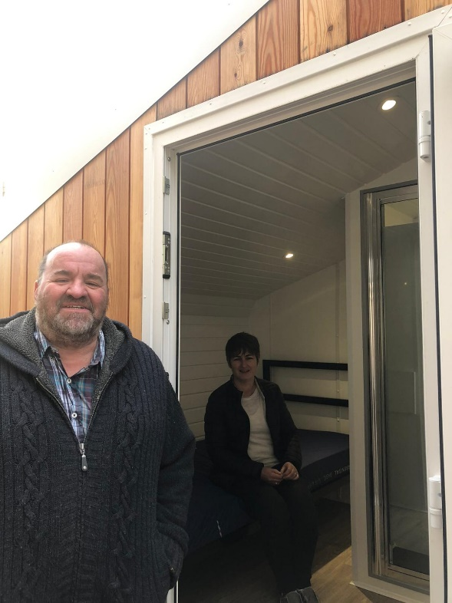After giving my accommodation the once over Naomi took me inside the adjacent building known as The Third Place. This is when the scale of what the church are creating here. I walked into a beautifully finished coffee shop and was offered a hot drink (I thought was a good way to start my evening). We sat down and Naomi started to explain her vision and what services they offer.

Church in Nantucket recently renamed The Third Place offers so much more! Along with the temporary accommodation to the rear, they have an on-site coffee shop, varying support groups, access to counsellors who provide support and advice covering topics such as addiction support, debt advice, prayer, and a safe environment for people to chat over an impressive array of hot and cold beverages. There is also access to the internet and on the right day of the week there are freshly baked goodies to enjoy and these fill the coffee shop with the most amazing smell! There is a large function room and a room available for our Support workers to meet clients, in a safe and secure environment.

Naomi also emphasised that she did not want people using the pods to feel isolated or secluded, they can spend all day in the coffee shop talking away and being amongst people who will just listen. Another fantastic thing that this café offers is a buy and bless scheme, customers can prepay for coffee, tea, cake etc. these get listed on a display board then one of the volunteers can bless someone else with that free item. A lovely idea!

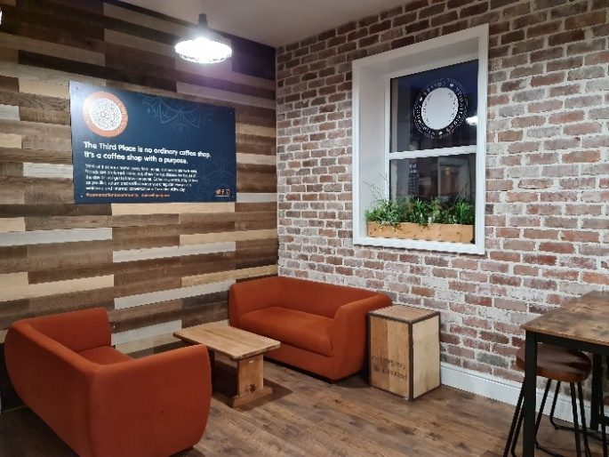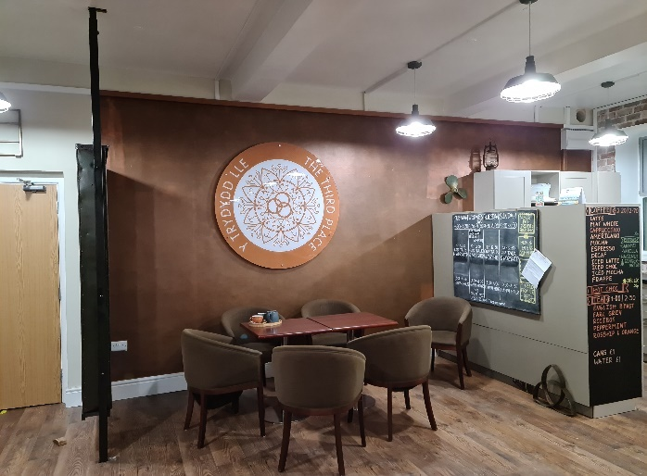

At this stage Pembrokeshire Care Society’s new MD Michael Hooper arrived and discussions soon flowed around visions of the future, our working partnership and what we can do to help those who need our help in Pembrokeshire. This was an inspiring discussion to be a part of and I am sure could have gone on for many hours….

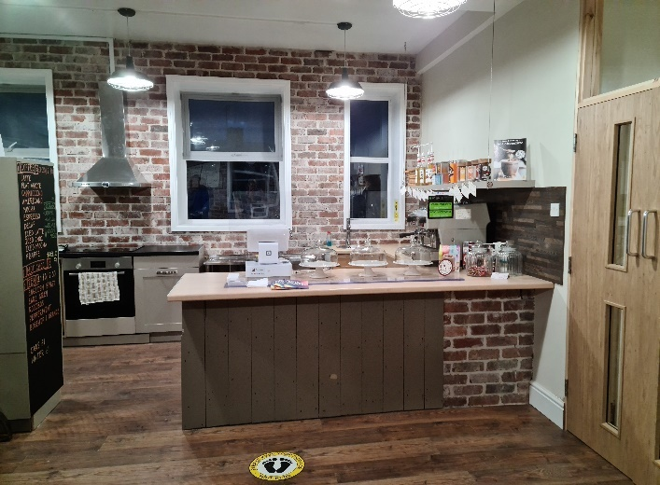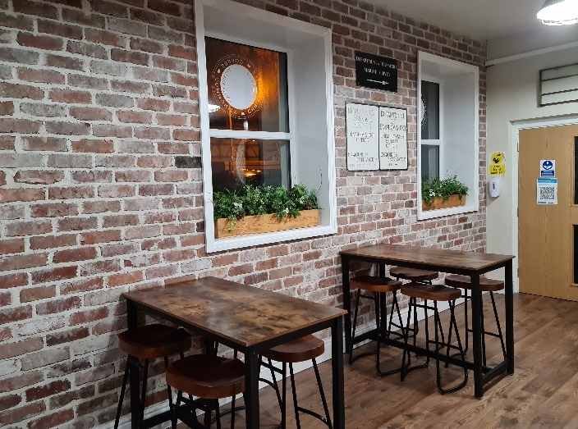

***Then the time had then arrived for me to get better acquainted with my accommodation.***

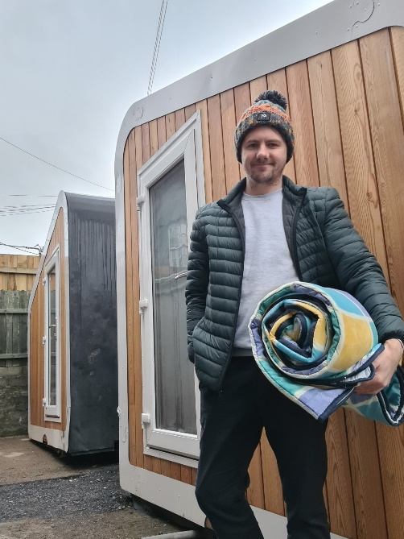**POD Life**

The Pods as I mentioned before are not huge, but once you are inside its surprising how much room you have. They contain a single bed, radiator, microwave, kettle, electricity, and a separate door leads you to your en-suite containing shower sink and toilet. I set up my sleeping bag and started to think about my evening meal. As part of the Pod offering, our clients will be provided with an emergency pack this will contain things such as sleeping bag, flask, bowl, cutlery, mug, hygiene pack (containing soap toothpaste toothbrush) and some basic food to support them and provide energy. These are non-perishable items, pot noodles/pasta pots, tins of tuna, baked beans, soup, porridge chocolate biscuits etc. There is a kettle on site and with tea bags and milk also provided, a hot cup of tea can go along way. Naomi is also in discussions with some local cafes in town to offer a free hot meal to those who will be using the Pods.

After my pasta pot and tin of tuna (I eat this out of the tin at home) I settled in for the evening. Like most people I had my phone to keep me somewhat entertained and enjoyed reading mostly supportive messages from my colleagues 😊.

**Sleep + Facilities**

Before I knew it, the 10 o clock horses were coming for me, and I drifted off to sleep dreaming of what my breakfast may contain. (unfortunately, not the fry up I was craving) I am a light sleeper and woke around 2.30am the reason…. I was too warm! Considering what these pods are designed for it was a pleasant reason to awake from my slumber. With that, I turned off the electric radiator re-arranged my PJ’s and shut my eyes once more.

I woke up around 7.30am (a lay in for me!) pulled up the privacy roller blind on the door to reveal day light. I popped on the kettle so I could make a nice cup of tea and my porridge pot.

Next in the routine was shower time! The facilities are fantastic I was able to have a hot shower and

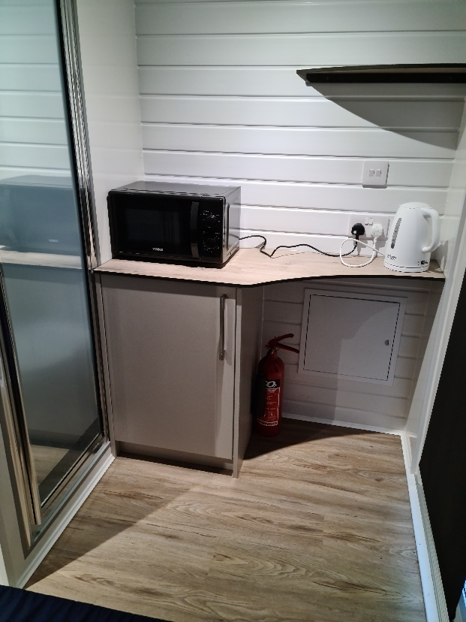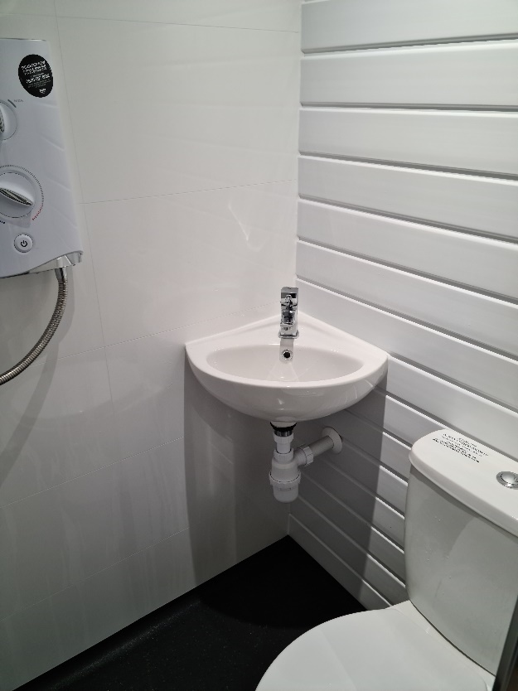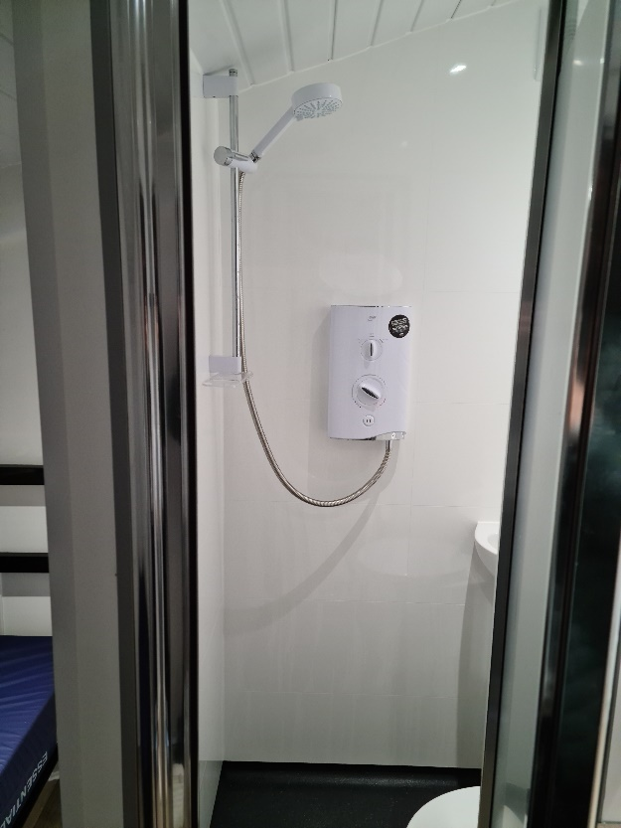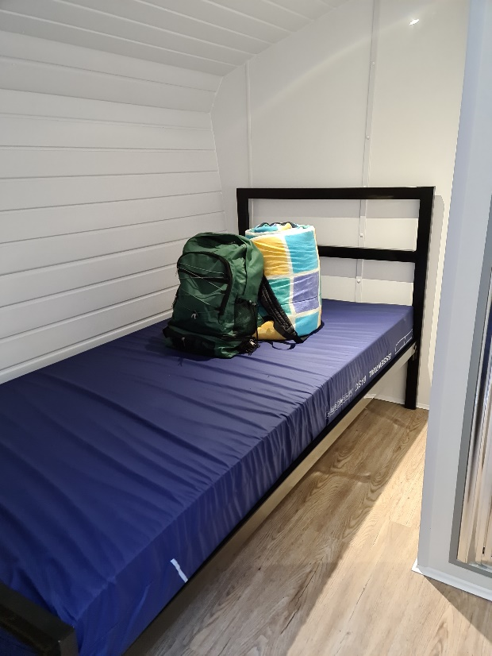feel fresh for the day ahead, something that should not go under the radar.

With that I was ending my journey, to be honest I was a little sad to go.

What struck me most from my experience was the little details that will mean so much, the hot food, countless amount of tea, the support you are provided, the shelter from the rain and wind, the warmth and probably the biggest thing for me was the security. They are in a secure location; the Pods have their own locks and that makes a massive difference. I found the whole project inspiring; Naomi was so passionate and keen to help no matter peoples background, with the coffee shop and the support services it provides this really is a special place.



With that said I will now sign off until next time….

Stay safe, JC